Grade 2 Supply List
2023-2024
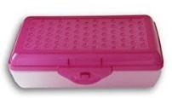  1 plastic pencil box | 2 boxes of crayons OR colored pencils (24 count) | 1 pair scissors  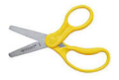
3 marble notebooks  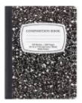 | Highlighters  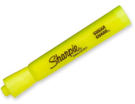 | Pink erasers  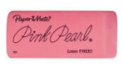
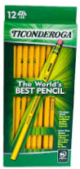  Supply of #2 sharpened pencils (preferably Ticonderoga) | Supply of glue sticks  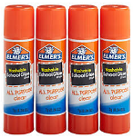 | 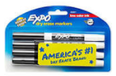  12 SKINNY Low Odor Dry Erase Markers
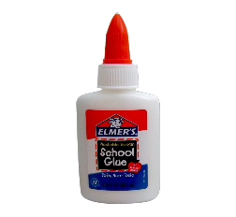  One small bottle of Elmer’s Glue  This Photo by Unknown Author is licensed under CC BY-NC | 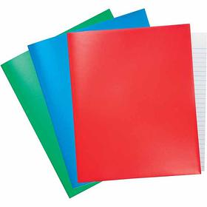  One plastic 3-prong folder | Headphones
Optional Items
3x3 post it notes
Washable Crayola markers
1 box of tissues
1 container of wipes
1 bottle of hand sanitizer
1 bottle of hand soap
1 box of Ziploc gallon bags
1 roll of paper towels

Many of these items from the supply list will need to be replenished as they are used throughout the year. Also, please be sure to read with your child this summer. We have included a list of books on the back to get your child started with his/her selections. Enjoy!

Dear Parents:
Below is a suggested reading list for over the summer. It is very important to keep your child’s skills sharp. We have included both fiction and non-fiction selections. Enjoy!
The Second Grade Teachers

Fiction:
- Science Verse
- Ready Freddy: Don't Sit on My Lunch, Ready Freddy Series
- Down Girl and Sit: Smarter than Squirrels
- Velma Gratch & the Way Cool Butterfly
- Nim's Island
- Sneakers, the Seaside Cat
- Atomic Ace (He's Just My Dad)
- Dude, Where's My Spaceship?

Nonfiction:
- It's Disgusting and We Ate It!: True Food Facts From Around the World and Throughout History
- Michael Recycle
- The Flyer Flew! The Invention of the Airplane
- Roberto Clemente: Pride of the Pittsburgh Pirates
- Sixteen Years in Sixteen Seconds: The Sammy Lee Story
- Shipwreck at the Bottom of the World: The Extraordinary True Story of Shackleton and the Endurance
- My Librarian Is a Camel: How Books Are Brought to Children Around the World
- The Busy Body Book: A Kid's Guide to Fitness

Recommended Series for Second Graders
- Ready Freddy
- Diary of a Wimpy Kid
- My Weird School
- Nancy Drew
- Horrible Harry
- A to Z mysteries
- Young Cam Jansen

